Help for Exam 4
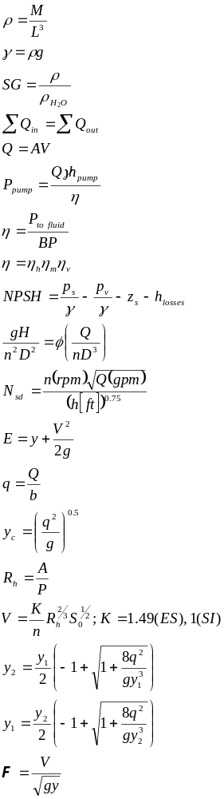

p_{atm} = 14.7 psia
p_{atm} = 100 kPa abs
g = 32.2 ft/sec²
g = 9.81 m/sec²
1 horsepower = 550 ft-lb/sec
1 watt = 1 N-m/sec
1 ft = 12 in
1 ft³ = 7.48 gal
1 min = 60 sec
1 hr = 60 min
1 mile = 5280 ft
°K = °C +273
°R=°F+460

